CFD Analysis on Preliminary Layout of 2.5 m Continuous Wind Tunnel

K. Siva Kumar ¹, Vishal S. Shirbhate ², Keshav S Malagi ³

^{1, 2, 3} Computational and Theoretical Fluid Dynamics Division,
Council of Scientific and Industrial Research - National Aerospace Laboratories,
Bangalore - 560017, Karnataka, India
Email Id: sivakumar@nal.res.in ¹, vishalss@nal.res.in ², keshav@nal.res.in ³
Abstract
In the present CFD study, an attempt has been made to carry out three-dimensional steady flow simulations on the proposed preliminary layout of 2.5m Continuous Wind Tunnel (CWT). The proposed geometry for achieving Mach 4 in the test section has been considered. The objective of the current study is to assess the flow uniformity at the test section and flow patterns throughout the tunnel for the proposed design. The understanding of the flow behaviour would assist in the design phase of a continuous wind tunnel programme. Structured hexahedral meshes over 3D configuration have been generated using Pointwise grid generation tool. ANSYS Fluent tool has been used for CFD simulations.
Keywords: CFD, FMG, Continuous Wind Tunnel (CWT), k-ε, flow separation

- Introduction
The CSIR-NAL presently operates a 1.2 m trisonic blowdown wind tunnel facility that was started in 1957. It has been successfully supporting most of the national aerospace programmes running in the country. However, to cater the needs of major aerospace programmes in civil and strategic sectors, there is a need to build continuous wind tunnel facility which provides a longer run time with better airflow quality, low noise and low operating costs. Towards this goal, the CSIR-NAL has proposed to set up a 2.5 m Continuous Wind Tunnel (CWT) national facility. There is no prior experience of designing such tunnels in the country which involves complex aerodynamics. To help in designing such a complex aerodynamic facility, CFD studies can provide very good insight [1-5]. Hence, it has been decided to employ CFD right from the initial design phase of CWT. This is possible because of the availability of good CFD codes and high computational power available with ICE / ANANTHA supercomputer at CSIR-4PI. In the present study, the proposed geometry for achieving Mach 4 at the test section has been considered. Structured hexahedral meshes over 3D configuration have been generated using Pointwise [6] grid generation tool. The CFD package ANSYS Fluent tool [7] has been used for CFD simulations. The following sections provide the details of the study and solver setups.
- Grid Generation
Structured hexahedral mesh with Y+ (≈ 4) is maintained at the walls of the entire wind tunnel to resolve the characteristics of the boundary layer. The mesh generation has taken care of capturing shock patterns near the wedge. All the grids are generated using Pointwise; the details are shown in Fig 1(a) and (b). Table 1 indicates the mesh size for two different cases with and without a wedge.
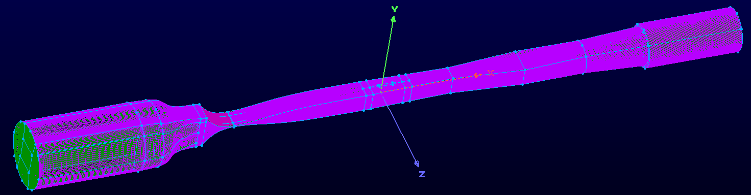
(a)
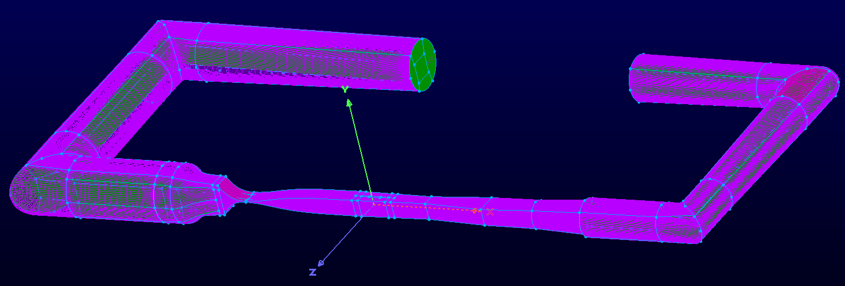
(b)
Fig. 1 Structured grids for CWT (a) without corner bends (b) full layout
Table 1. Mesh size for two different configurations
Case | Configuration Type | Without wedge (approx. no of cells) | With wedge  (approx. no of cells)
a | 3D CWT without bends | 3.2 million | 3.67 million
b | 3D CWT full layout | - | 7.11 million

3. CFD Solver and Boundary Conditions
The CFD package ANSYS Fluent numerical code is used for predicting the flow characteristics inside the wind tunnel by solving 3D steady RANS equations. A pressure based coupled solver was selected; second order discretization was applied for the equations to increase the accuracy of the results. The k-ε turbulence model is used, and a special initialization technique called Full Multi-Grid (FMG) initialization has been implemented for better initial guess values and better convergence acceleration.
As boundary conditions, the static pressure of 0.15 bar and total temperature of 300º K at the outlet has been calculated using isentropic relations corresponding to the desired Mach number of 4 and a total pressure of 1.5 bar.
- Results and Discussions
In the present CFD study, a three dimensional RANS simulations are performed on the proposed full layout of 2.5m Continuous Wind Tunnel. The result in Fig. 2 and Fig.3 displays the Mach number contours plotted in two different planes (XY and XZ) inside the wind tunnel without and with wedge, respectively. The result in Fig. 4 (a) and Fig. 4 (b) displays the streamlines through 3D CWT layout without and with the wedge where the non-uniformity of the flow is observed. Fig. 5 displays the static pressure contours through 3D CWT layout. Higher pressure is observed in the left portion of the layout and it is constant in the test section region as expected. The Mach number contours are shown in Fig. 6, the shock pattern near the leading edge of the wedge is observed. It can be seen in the pressure line contour plot. Velocity vector plots at four corner bends and near the wedge of the wind tunnel also plotted in Figs. 7 (a), (b), (c), (d) and (e) respectively to see the flow separations. The recirculation of flow was observed in all the four corner bends and near wedge. Fig. 8 represents the contours of velocity magnitude at various cross-sections, starting from a throat to the diffuser region (x =13, 15, 20, 25, 30, 35, 40, 45, 50m) where the development of the boundary layer can be seen near the test section region. The streamlines through 3D CWT full layout with the wedge is shown in Fig. 9, where the non-uniformity of the flow is observed near wedge. The unsteady flow near the test section can be observed which was caused by the flow separations in the upstream and downstream side of the wind tunnel corners where the flow turn by 90°. The wall Mach number is plotted in Fig. 10, where the flow symmetry is observed at the top and bottom surfaces of the test section. In all the cases, a good convergence is observed and the desired Mach number of 4 was also achieved.
- Conclusions
A 3D RANS simulation using ANSYS FLUENT and POINTWISE over a preliminary layout of 2.5m Continuous Wind Tunnel has been attempted using CSIR-4PI computing facility. These computational analyses were performed to provide a general description of the flow inside the wind tunnel. This analysis, allowed for the understanding of the flow characteristics not only in the test section but also the flow in other important sections of the wind tunnel. Results have been obtained with very good convergence in all the cases. Boundary layer formation and velocity distribution have been captured well. The simulations demonstrated that the desired Mach number of 4 can be achieved. Additional detailed analysis will be conducted as the design progresses.
- Acknowledgements
The authors would like to acknowledge the NTAF team for providing CAD geometry and flow conditions. The authors would like to thank Dr J.S. Mathur, Head and Dr V. Ramesh, Jt. Head, CTFD Division, and Director, CSIR-NAL for their kind support.
References
1. Mehta R.D.; Bradshaw, P. Design rules for small low-speed wind tunnels. Aeronaut. J., 83, 443-449,1979.
2. Cermak, J.E. Wind tunnel design for physical modelling of the atmospheric boundary layer. J. Am. Soc. Civ. Eng., 107, 623-642, 1981.
3. Mehta, R.D. Turbulent boundary layer perturbed by a screen. AIAA J., 23, 1335-1342, 1985.
4. Launder, B.; Spalding, D.B. Lectures in Mathematical Models of Turbulence; Academic Press: Waltham, MA, USA, 1972.
5. Lastra, M.R., Oro, J.M.F., Vega, M.G., Marigorta, E.B. and Morros, C.S., Novel design and experimental validation of a contraction nozzle for aerodynamic measurements in a subsonic wind tunnel. Journal of Wind Engineering and Industrial Aerodynamics, 118, pp.35-43, 2013.
6. Pointwise: http://www.pointwise.com
7. ANSYS Fluent: http://www.ansys.com/Products/Fluids/ANSYS-Fluent

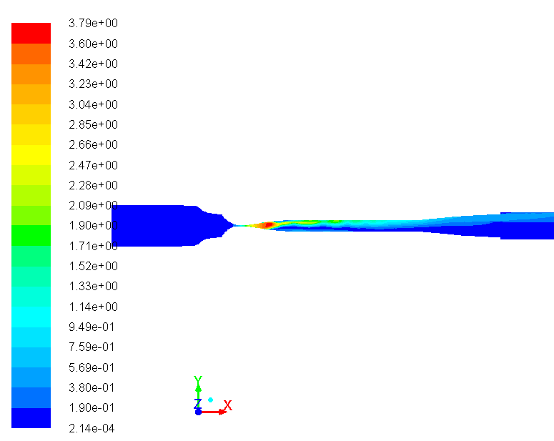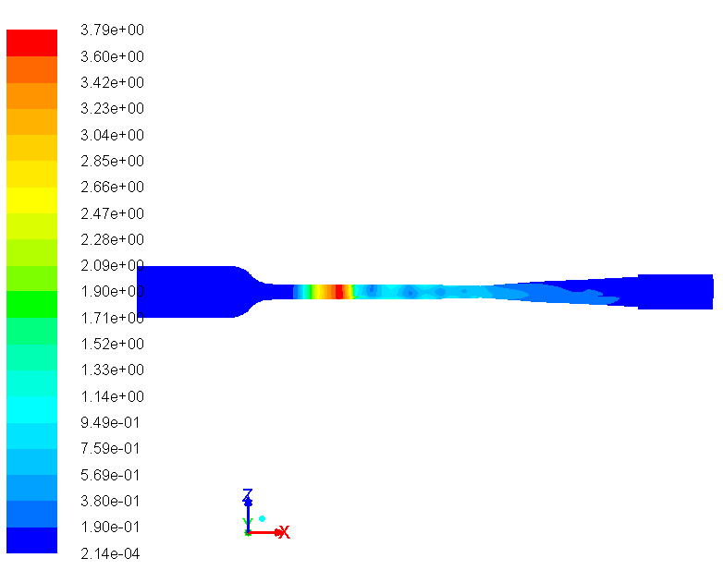
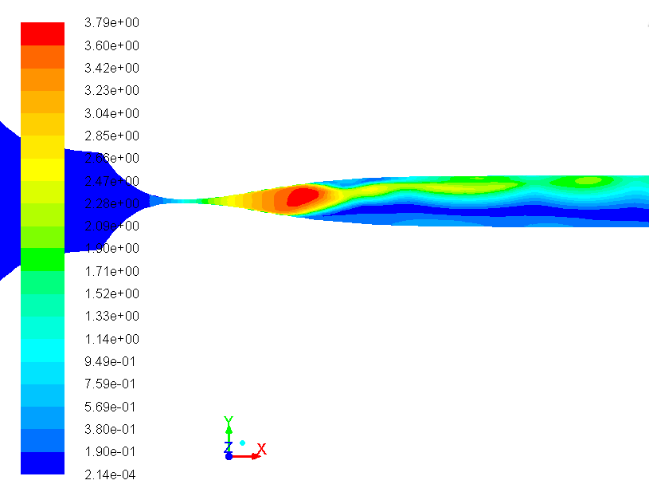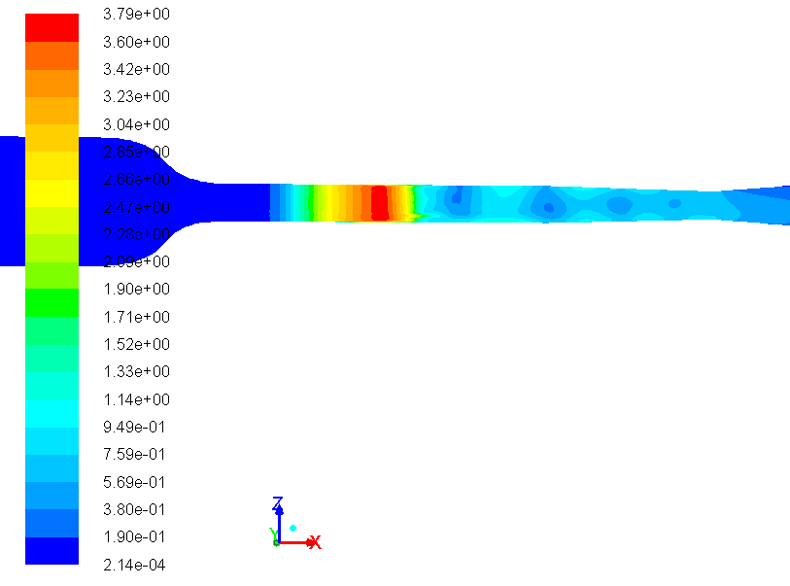
Zoomed view
Zoomed view
(a) XY-Plane
(b) XZ-Plane
Fig. 2 Sectional contours of Mach no. on 3D CWT without bends (without the wedge)
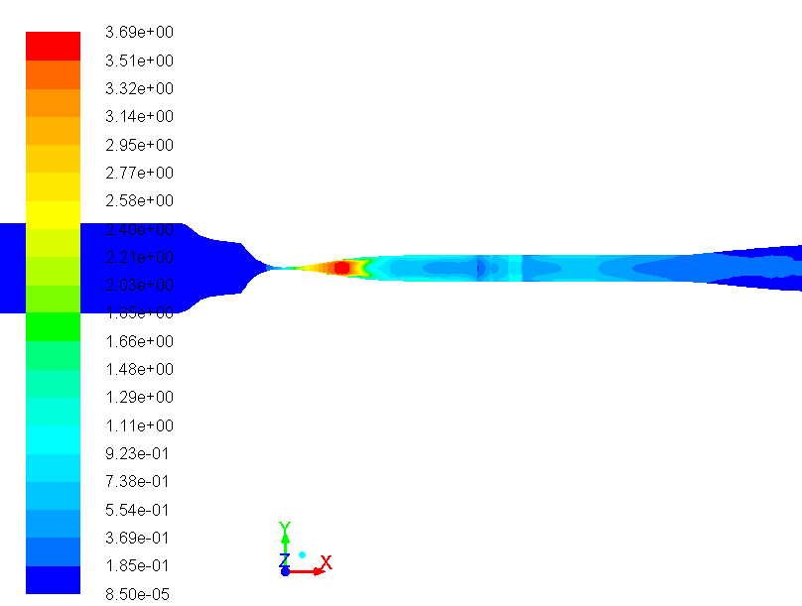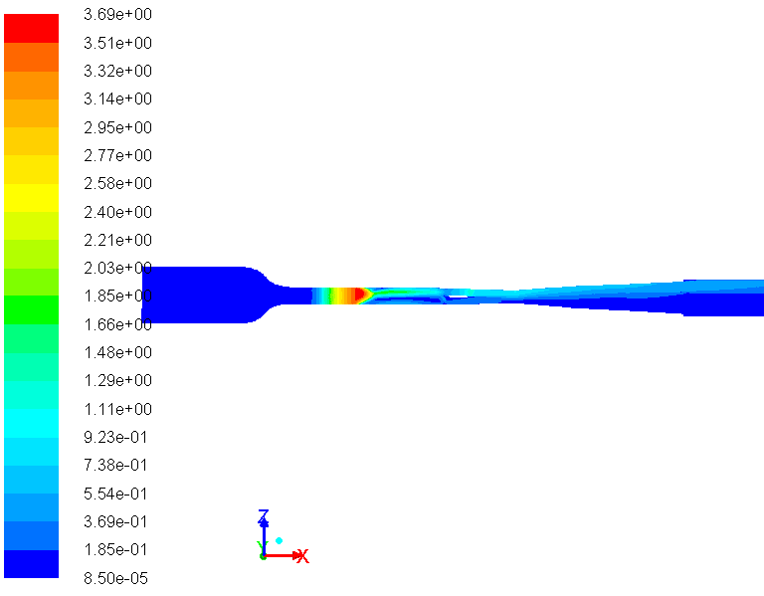
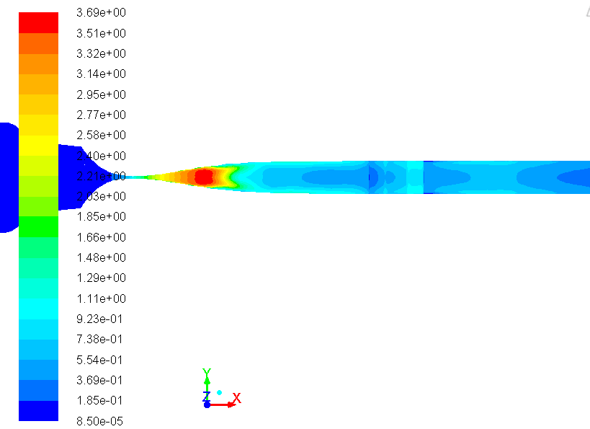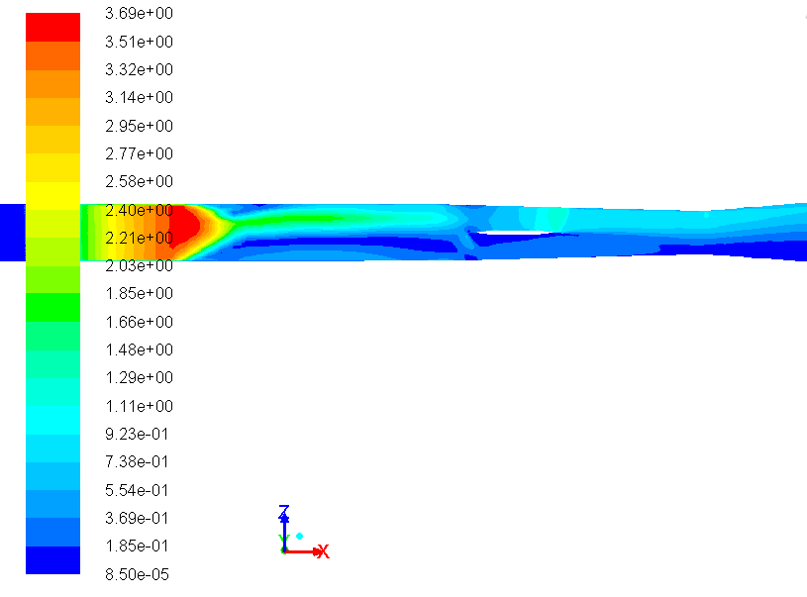
Zoomed view

Zoomed view

(a) XY-Plane
(b) XZ-Plane
Fig. 3 Sectional contours of Mach no. on 3D CWT without bends (with the wedge)
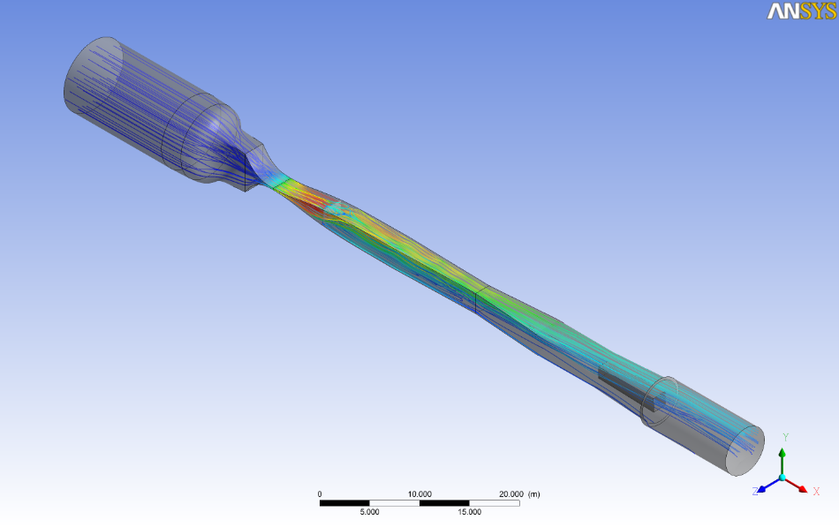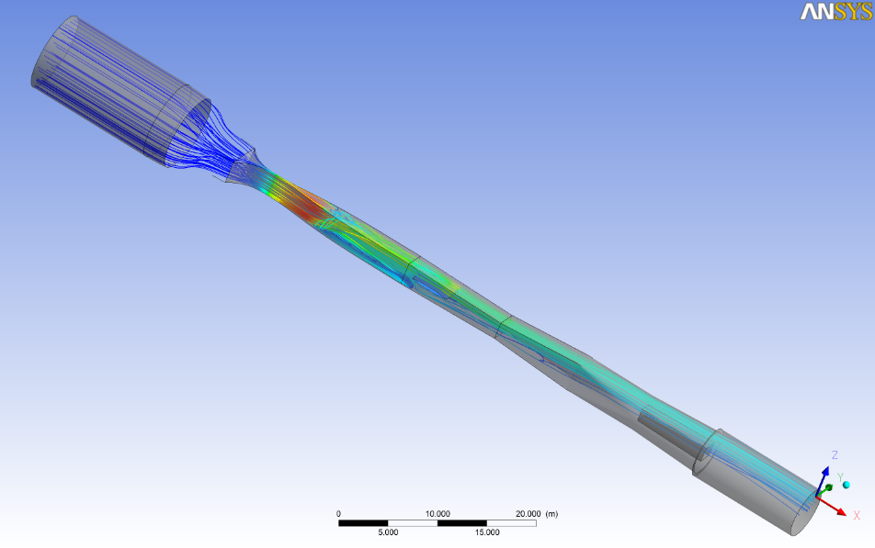
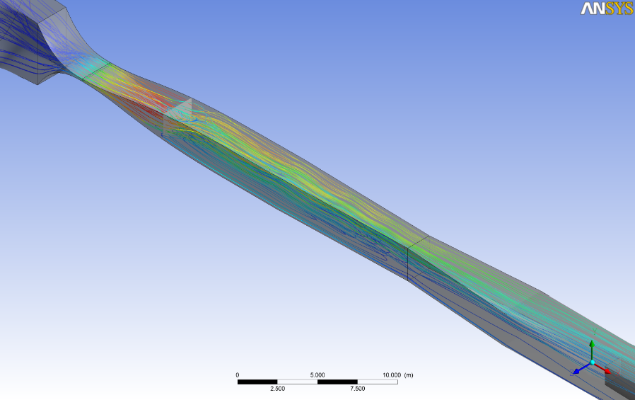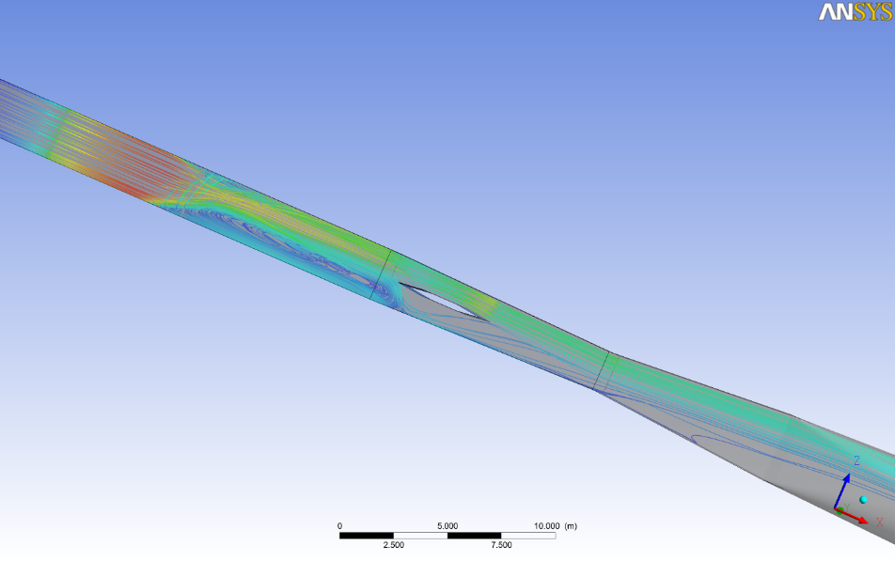
Zoomed view

Zoomed view

(a) Without the wedge (b) With the wedge
Fig. 4 Streamlines through 3D CWT without bends
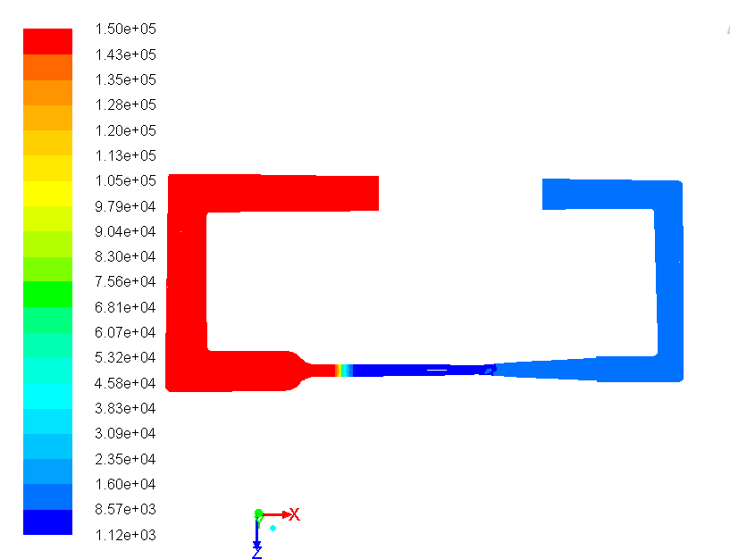
Fig. 5 Contours of static pressure on 3D CWT layout (with the wedge)
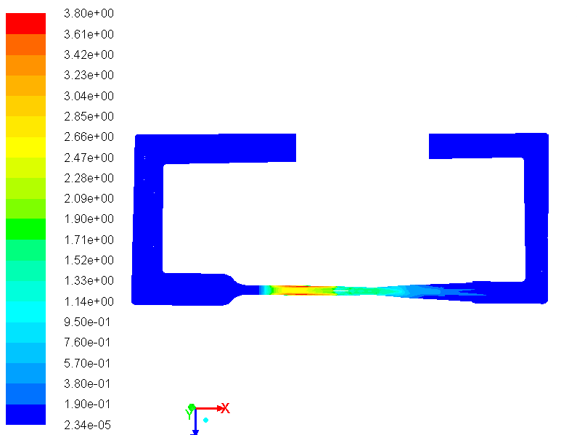
Zoomed view

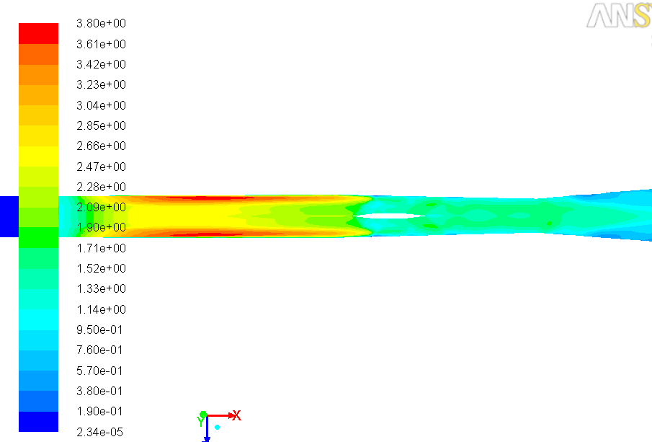
Zoomed view

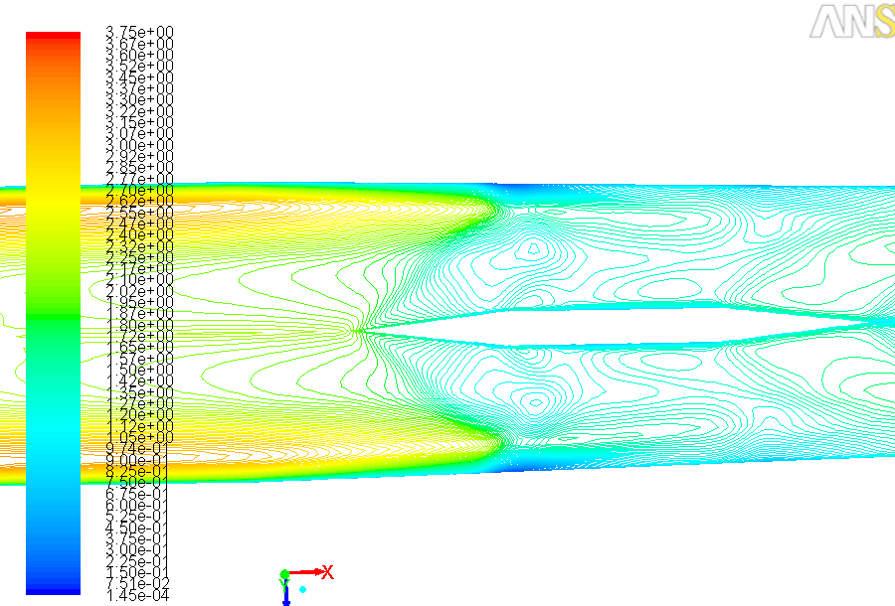
Fig. 6 Contours of Mach No. on 3D CWT layout (with the wedge)
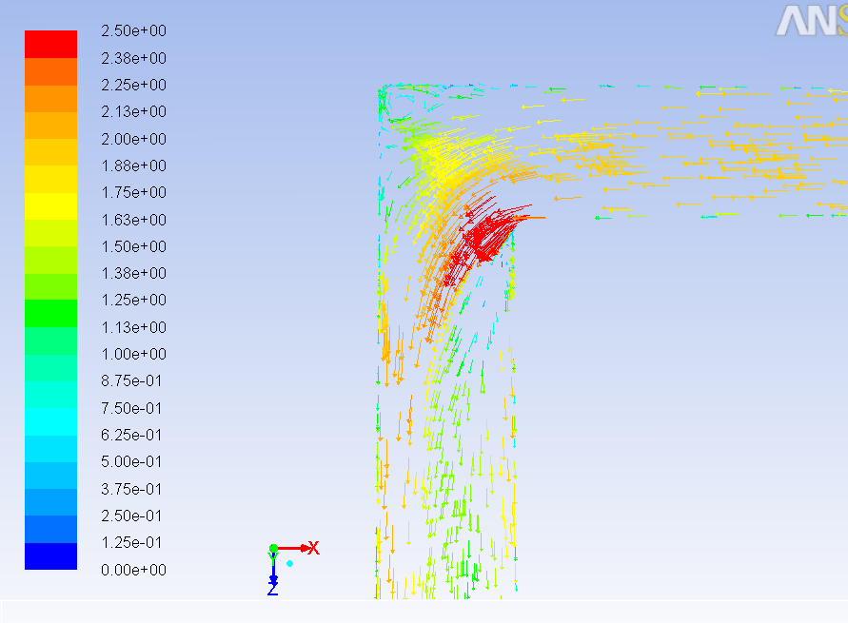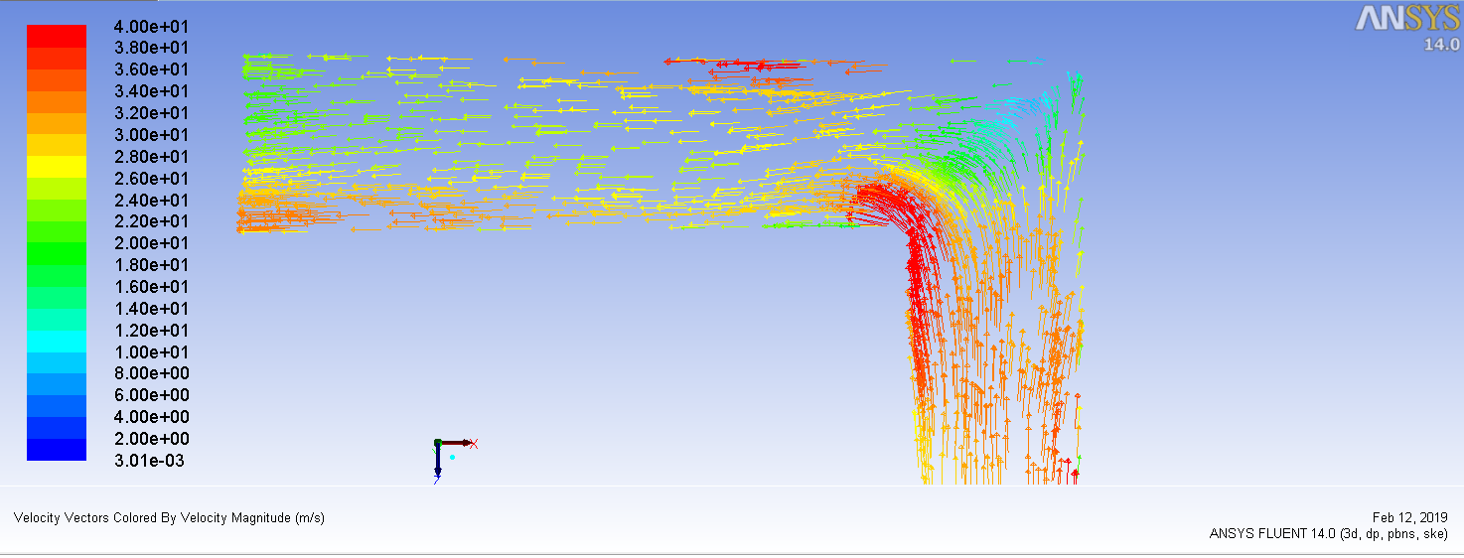
Recirculation

Recirculation

(a) Top left corner bend (b) Top right corner bend

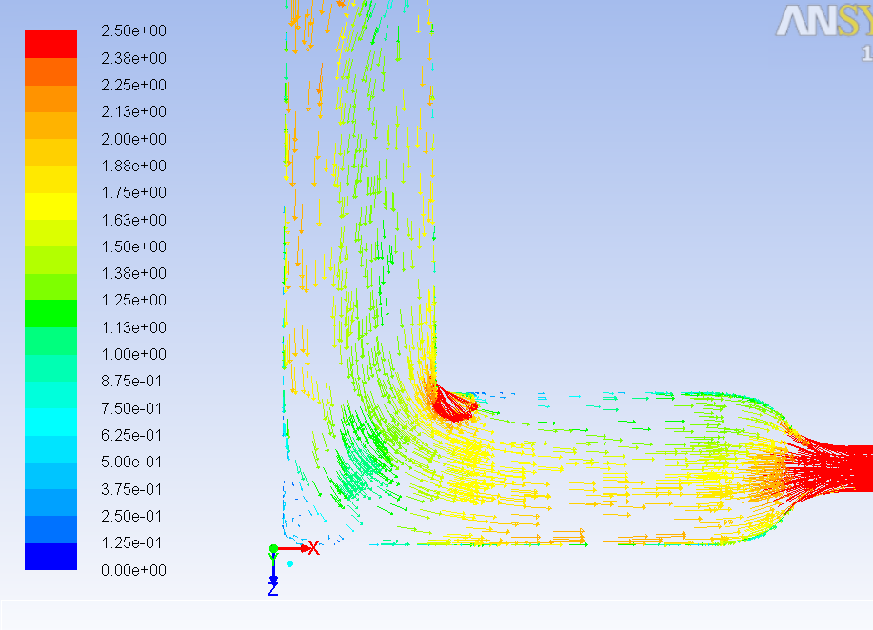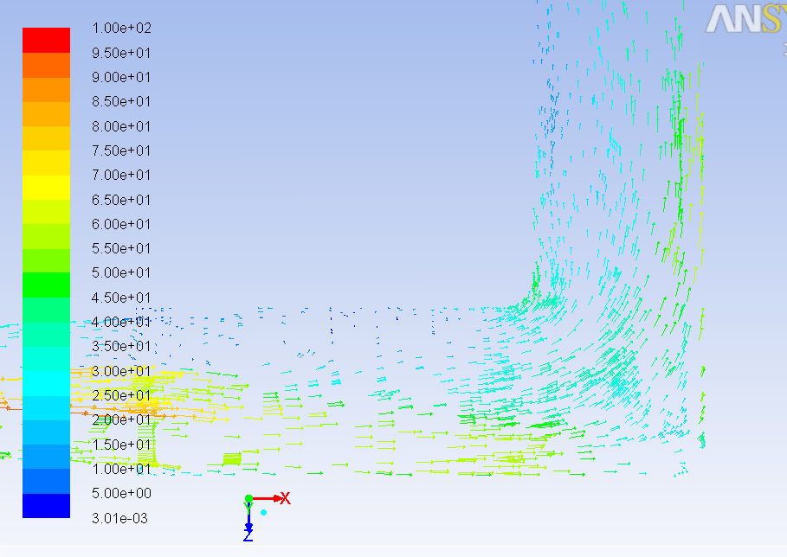
Recirculation

Recirculation

(c) Bottom left corner bend (d) Bottom right corner bend

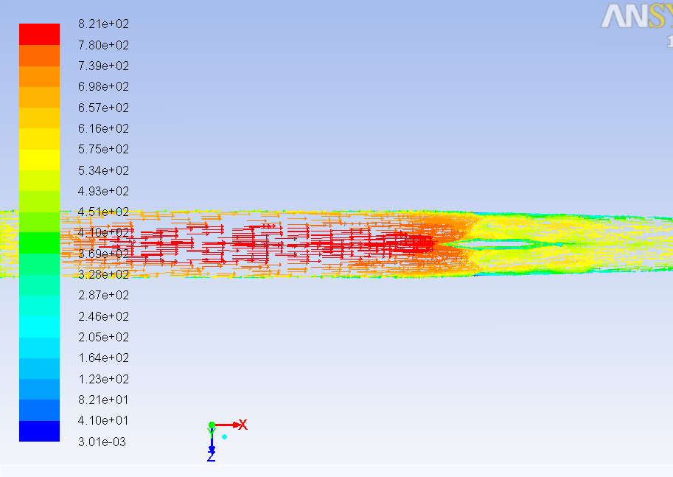

(e) Near wedge
Fig. 7 Velocity vectors on the corner bends and a near the wedge of the CWT layout

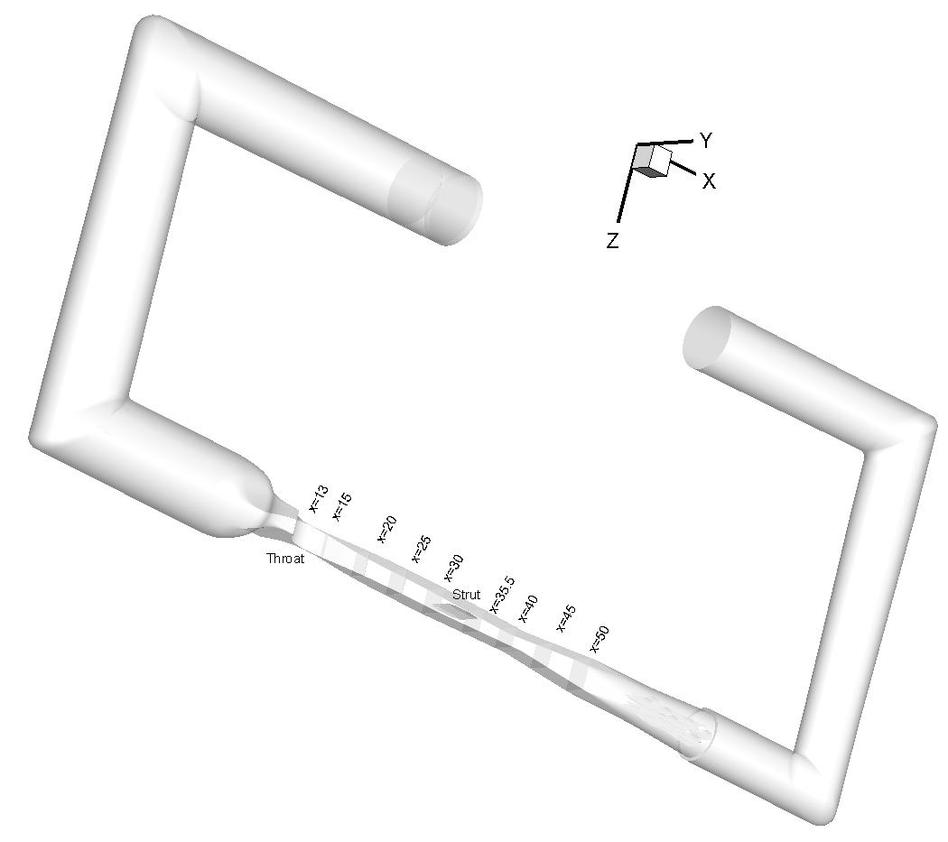

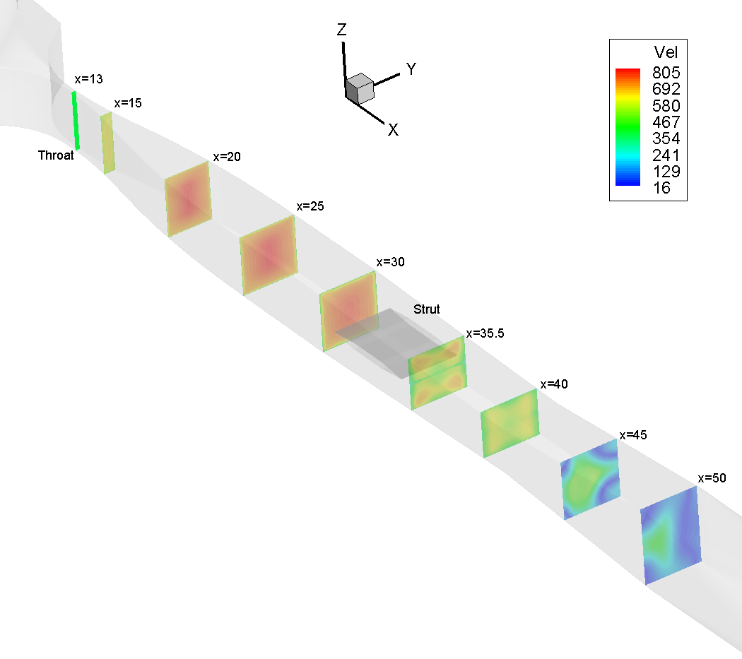
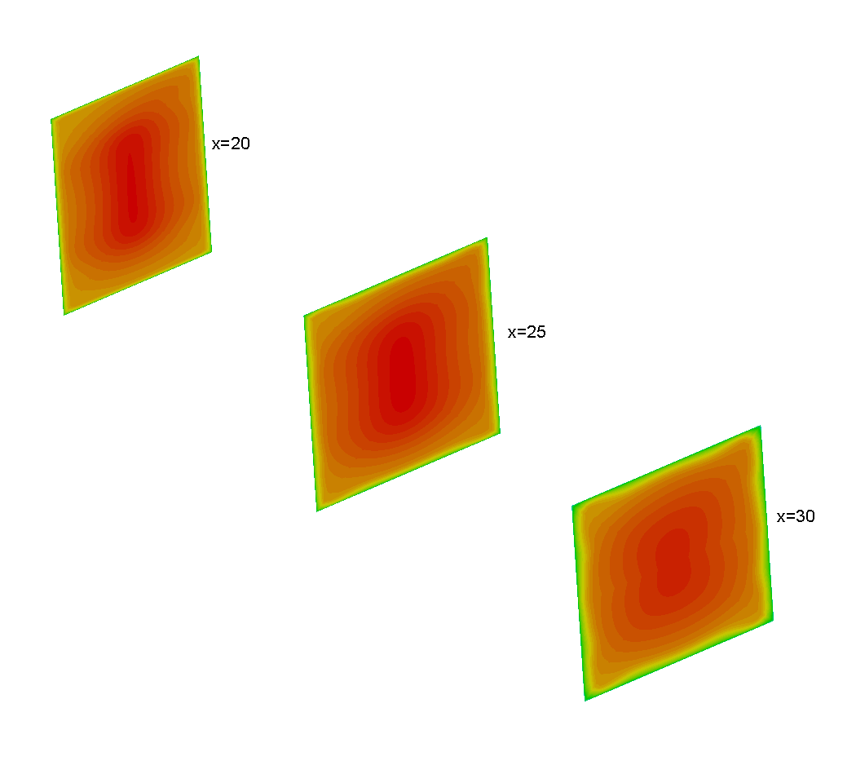
Development of the boundary layer near test
section

Fig. 8 Velocity contours at various cross-sectional planes (m) x=13, 15, 20, 25, 30, 35, 40, 45, 50
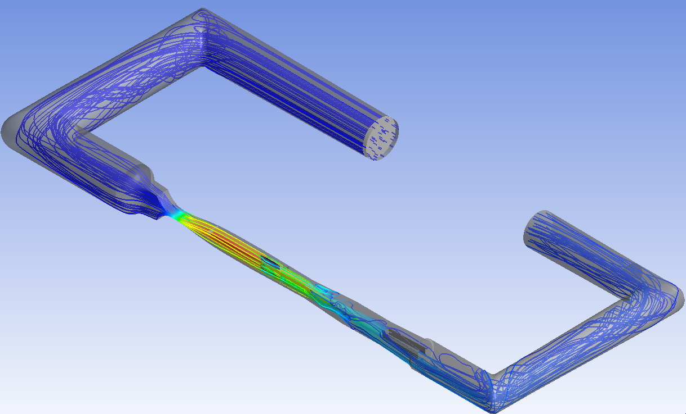

Fig. 9 Streamlines through 3D CWT full layout

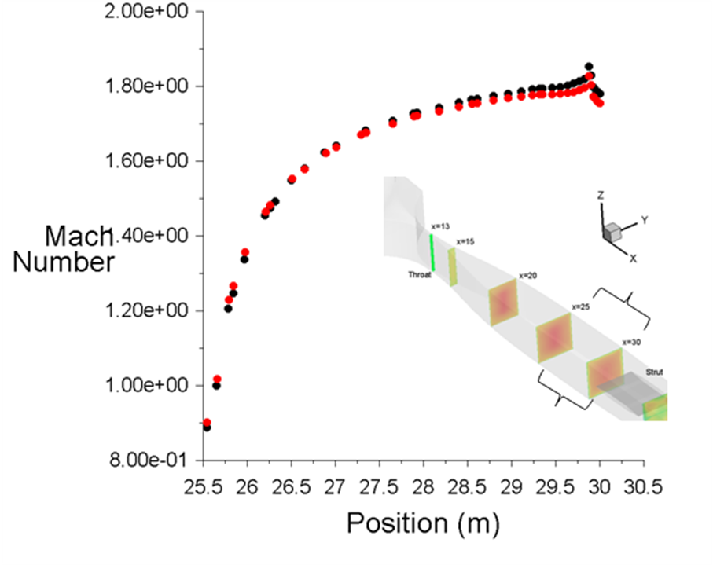
Fig. 10 Wall Mach number plotted near the test section of the CWT layout

